Ivan Dikic
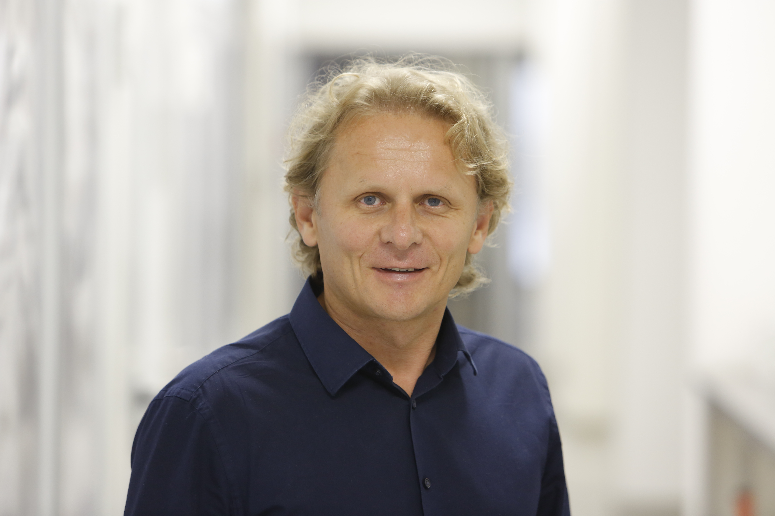

Goethe University Frankfurt, Germany
Max Planck Institute for Biophysics, Frankfurt

Ivan Dikic, M.D., Ph.D. is Professor of biochemistry at Goethe University and a Fellow of Max Planck Institute for Biophysics in Frankfurt. The Dikic lab studies molecular principles of ubiquitin biology and autophagy and explores pathological alterations in these pathways related to human disease development. His recent interests focus on selective autophagy of ER (ER-phagy) and understanding host-pathogen interactions during bacterial and viral infections.
He is an elected member of the EMBO, the German National Academy of Sciences Leopoldina and the American Academy of Arts and Sciences. For his scientific work he received multiple awards including the Hans Krebs Award, the Jung Prize for Medicine and the Leibniz Prize (the highest scientific distinction in Germany). Ivan Dikic is committed to education of the next generations of young scientists globally and spends significant time and energy in organization of educational conferences and workshops.

Web: https://biochem2.com/research-group/molecular-signaling
LinkedIn: https://www.linkedin.com/in/ivan-đikić-a7b53527/
Twitter: @iDikic2
https://twitter.com/iDikic2

